# Ifelse()

ChickWeight %>%

mutate(Diet_name = ifelse(Diet == 1, 'A',

ifelse(Diet == 2, 'B',

ifelse(Diet == 3, 'C','D'))))

# Scrape HTML-Table

url %>%

read_html() %>%

html_table(fill = TRUE, header = TRUE) %>%

1. Zeile auswählen
2. Spalte /nauswählen

.[[2]] %>%

.[, c(1,2,5)] %>%

head(10)

# Remove Whitespace

trimws( which = c("both", "left", "right"), whitespace = "[ \t\r\n]")

# Unlist()

Liste 🡪 Chr

🡪 map(chr, function)

episodes.urls = unlist(episodes)

# Source Code

view-source:https://

cmd + Opt. + U

# Visualization

Regressionsgerade

🡪 gerade durch method = lm

🡪 keine Umrandung durch se

geom_smooth(method = lm, se = F)

Winkelhalbierende einfügen

geom_abline() +

ylim(0,50) +

xlim(0,50) +

coord_fixed()

cols = match(c("Mathe","Deutsch","Englisch","Bio"),

|  |  |  |  |  |
| --- | --- | --- | --- | --- |
| Schüler | Mathe | Deutsch | Englisch | Bio |
|  |  |  |  |  |

colnames(data))

date %>%

|  |  |  |
| --- | --- | --- |
| Schüler | Fach | Note |
|  | Mathe |  |
|  | Deutsch |  |
|  | Englisch |  |
|  | Bio |  |

gather(Fach, Note, cols) %>%

arrange(Schüler)

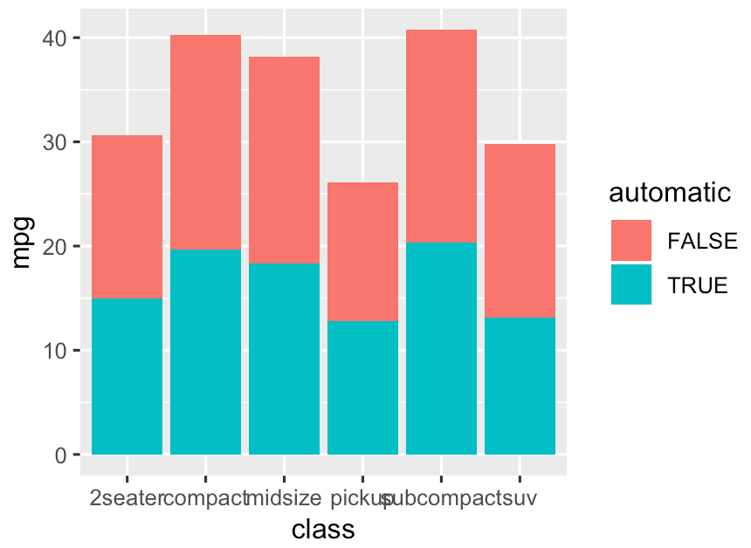

geom_bar(stat = 'identity')

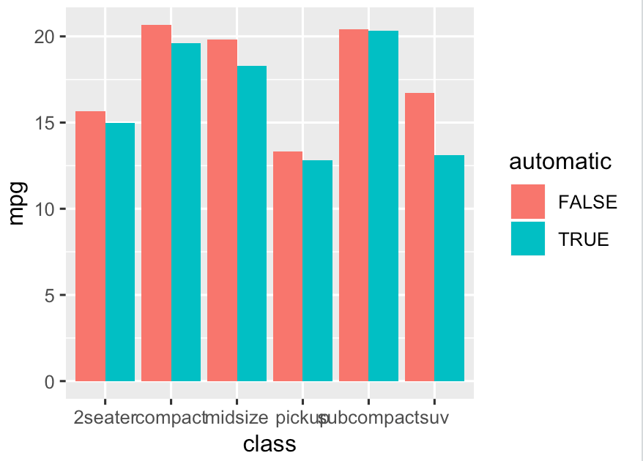

geom_bar(stat = 'identity', position = 'dodge')